Design Test

**Part 1: Answer the following questions in one or two paragraphs each:**

1. **What is your favorite non-Call of Duty single player experience and why? What part of the experience fell short of your expectations? What would you have changed?**

**Passage; Use of death is powerful, No right way to interpret the game, Every decision is meaningful and very decision-rich, rich resonance and empathy; Lack of rewards type, monotonic, player do not understand reward that easily, no feeling of getting one. More reward box deep down the maze.**

1. **You are asked to design the first fifteen minutes of the second hour of gameplay in a standard FPS campaign [ex: Call of Duty]. More specifically, you are asked to avoid using any run-and-gun first person shooter combat. What would be your design methodology in approaching this task? The thought process for planning and designing the gameplay described. Then give the concrete example in question 3.**

**Merge other game types into FPS. TD, Racing + static sniping, Stealth + dropping ear, Berserk, Escort + Assassination (Sniping), Support (Sniping在旁边保护移动的目标)**

1. **What is your design pitch for the gameplay from question 2? Make any assumptions about storyline/gameplay of the first hour of the campaign that you need to.**
2. **What are your primary sources (2 max) of inspiration for gameplay design? How have they informed designs you have created in the past?**

**Handcrafting and Watching Movies. Handcrafting often requires precision, following procedures one by one, small skills. Often inspired when designing puzzles. Like the game crush and Alpaca Village. Movie gives me inspiration as a whole, movies show me how things that I don’t usually deal with works. Like the stealth enemy AI I made I took example from action movies with assassin scene.**

1. **What is an environment that you have always wanted to experience FPS combat in? What specific elements of this environment make the gameplay more engaging or fun for the player? Please answer this question in the context of a typical Call of Duty experience (campaign, multiplayer, or zombies) and make sure to specify whether or not players have access to any advanced movement mechanics.**

**Castle. Multilayer, high ground, low ground. Inside, outside both have layers. Can be as complex as possible.**

**Part 2: Answer the following question in one page of text. Optionally, diagrams and photos may be included on additional pages.**

*Pick one of your favorite moments from an action film that involves gunplay. How would you convert this moment into a 5-10 min game experience? Along with the basic design, please make sure to explain: Why you chose this moment, the gameplay highlights that you expect players to respond to and the key game features that need to be used to complete your vision.*

*Edge of Tomorrow (Time rewind),* ***John Wick (Gun play with QTE)***



**Part 3: Draw a top-down layout for the following scenario.**

*You are working on a mission where the player must path through a warehouse to get to the objective. The warehouse is approx. 150’ x 200’. How would you lay out the interior? Please identify the entrance and exit points along with any cover, blockers, or enemies.*

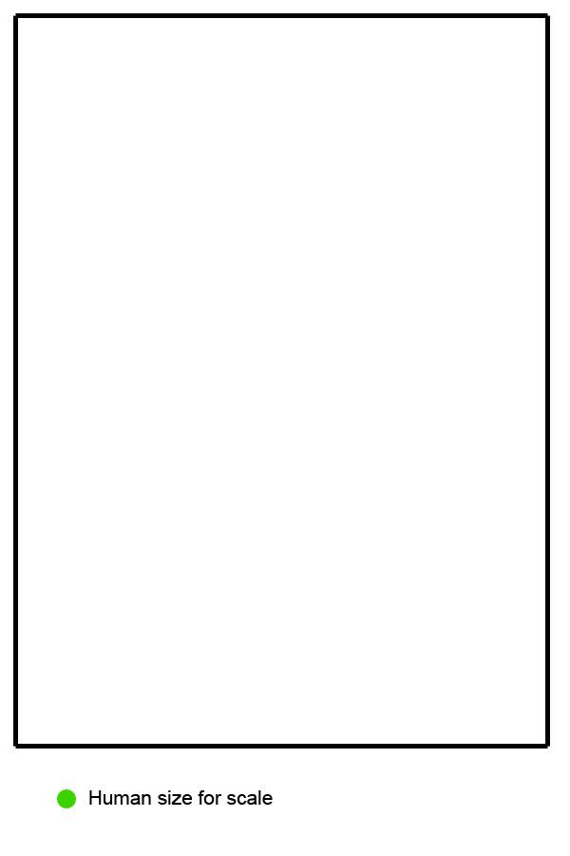

Some Ideas: Could have a portal like door.

**Part 4: Please attach a supporting document for the following prompt.**

*You are designing the in-game interfaces for social features. One particular feature allows you to:*

*See a list of all your friends online in the front end (main menu)*o *Add or remove players as friends*o *Prioritize some friends as “favorites” who will receive preferential treatment in-*

*game and in the list of friends*

*Using a simple wireframe, describe how the “favorited” players are treated relative to other players in any of the following: scoreboards, leaderboards, game stat comparisons, or any other place of your choosing where a list of players appears in a modern, next-generation console game.*